Name :-Kunal R Agarwal

SRN No:-201700110

Roll No:-18

Question:-**Implement the McCulloch-Pitts model**

**Write a program using python**

**Input:-**

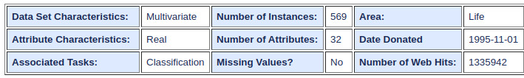

**Code:-**

import numpy as np

import pandas as pd

import matplotlib.pyplot as plt

from sklearn.model_selection import train_test_split

from sklearn.metrics import accuracy_score

import sklearn.datasets

cancer = sklearn.datasets.load_breast_cancer()

data = pd.DataFrame(cancer.data,columns=cancer.feature_names)

data["Class"] = cancer.target

x = data.drop('Class',axis=1)

y = data['Class']

x_train,x_test,y_train,y_test = train_test_split(x,y,test_size=0.2,random_state=3,stratify = y)

x_train_binarized = x_train.apply(pd.cut,bins = 2 ,labels = [1,0]).values

x_test_binarized = x_test.apply(pd.cut,bins=2,labels =[1,0]).values

class MP_Neuron:

def __init__(self):

self.b = 0

def Model(self,x):

return np.sum(x)>=self.b

def fit(self,x,y):

accuracy = {}

for b in range(x.shape[1] + 1):

self.b = b

yhat = []

for row in x:

yhat.append(self.Model(row))

accuracy[b] = accuracy_score(yhat,y)

best_b = max(accuracy,key = accuracy.get)

self.b = best_b

return [accuracy,best_b,accuracy[best_b]]

def predict(self,x,y):

yhat = []

for row in x:

yhat.append(self.Model(row))

accuracy = accuracy_score(y,yhat)

return accuracy

neuron = MP_Neuron()

accuracy, best_b, accuracy_model = neuron.fit(x_train_binarized,y_train)

print("The optimal value of b :",best_b)

print("accuracy_model on training data :",accuracy_model*100)

accuracy = neuron.predict(x_test_binarized,y_test)

print("The accuracy of model on test data is :",accuracy*100)

**Output:-**

